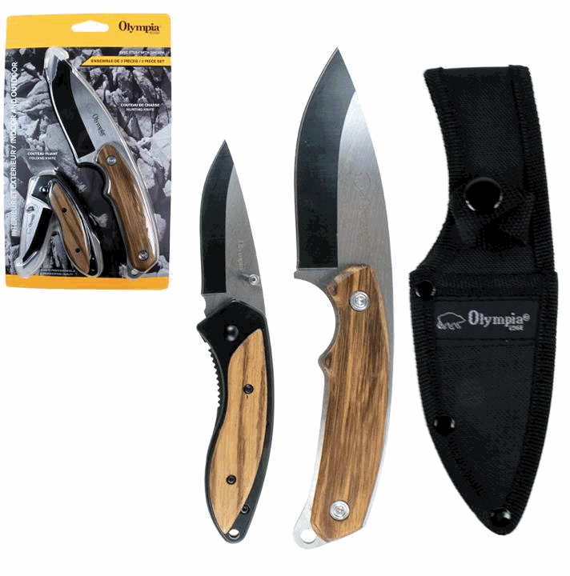

Quantity: 1,200
MSRP: $39.99
Wholesale: $17.50
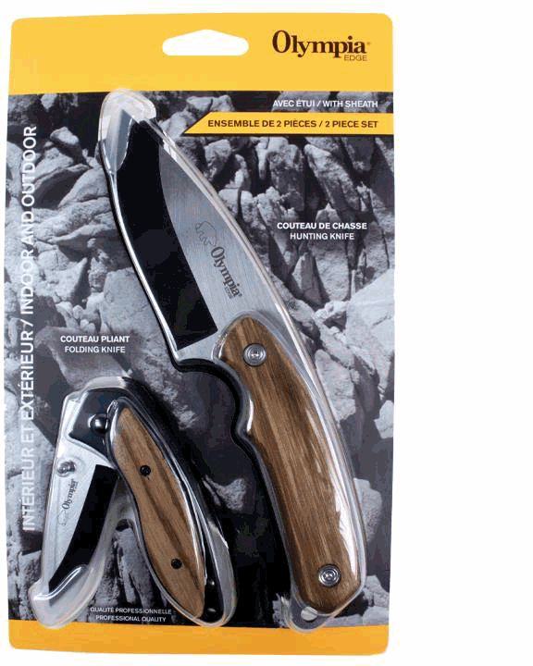
31455PKH
12/24
OLYMPIA - 2PCS HUNTING KNIFE SET OLYMPIA - COUTEAU DE CHASSE, 2MCX
*063315314552
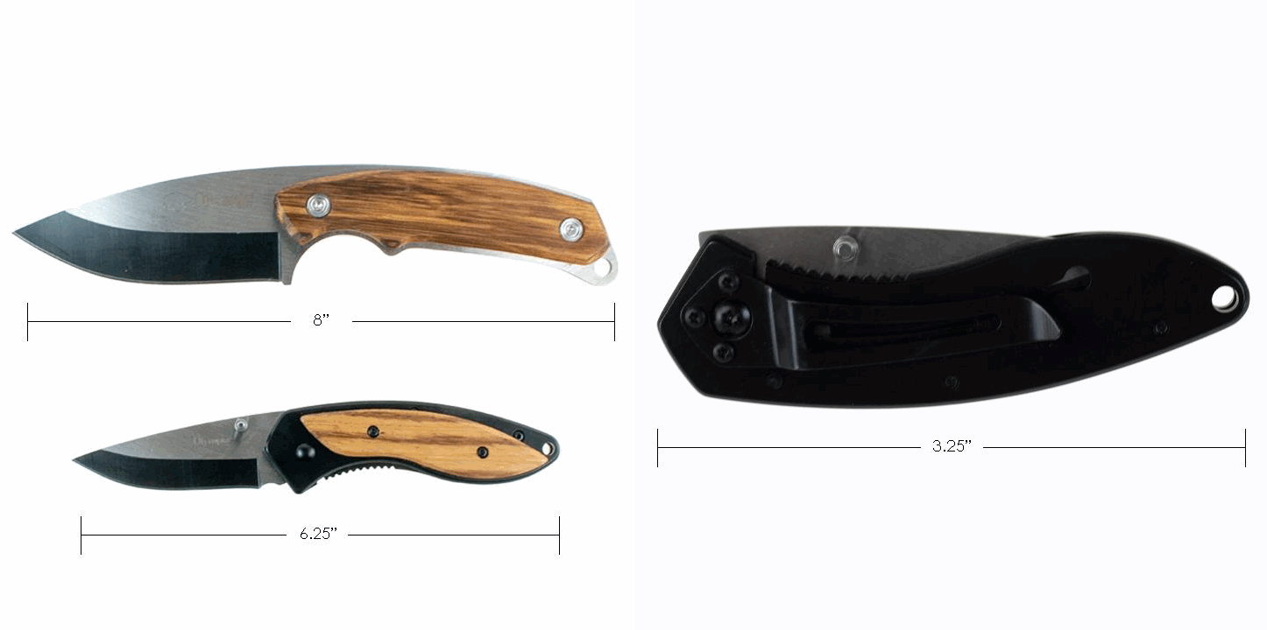08-22-2019
PG. 1

